2024 Summer Newsletter

10599 Twin Lake Rd NE Mancelona MI 49659

Phone (231)587-8354 Fax (231)587-4066

[www.bluelaketwpkalkaska.org](http://www.bluelaketwpkalkaska.org)

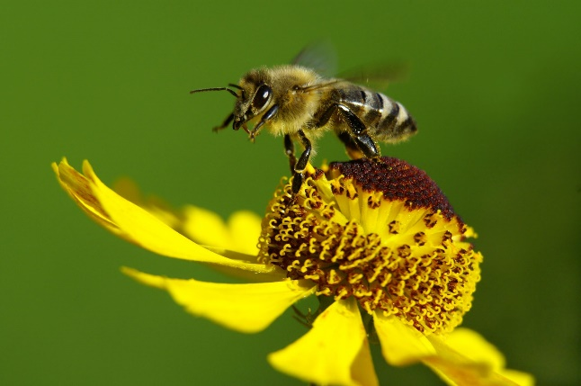

### Township Hall Office Hours

**Supervisor:** Thurs 1:00 PM – 4:00 PM

Sat 10:00 AM – Noon

**Clerk:** Tues 9:00 AM – 4:00 PM

**Treasurer:** Wed 10:00 AM – 1:00 PM

**Assessor:** 2nd & 4th Fri 9:00 - 11:00AM **(any day by appointment)**

**Zoning Dept:**  Fri & Sat 10:00 AM – Noon (**or by appointment)**

**(Oct 15-May 15 Wed 10:00AM-Noon, weekends by appointment)**

#### 

**Township Telephone Numbers You May Need:** ***(In an Emergency Call 911)***

|  |  |  |  |
| --- | --- | --- | --- |
| Supervisor | Blair Shearer | Home: 231-587-5698 | [blsuper@torchlake.com](mailto:blsuper@torchlake.com) |
| Clerk | Tracy Nichol | Home: 231-587-9644 | [blclerk@torchlake.com](mailto:blclerk@torchlake.com) |
| Treasurer | Christine Almose | Home: 231-587-9593 | [bltreas@torchlake.com](mailto:bltreas@torchlake.com) |
| Trustee | Mary Shaw | Home :231-587-8468 | maryshaw@torchlake.com |
| Trustee | Larry Shoemaker | Home: 231-587-0723 | gladysshoemaker90@yahoo.com |
| Township Assessor | Tom Sheneman | Home: 231-499-5039 | [blassessor@torchlake.com](mailto:blassessor@torchlake.com) |
| Zoning Admin | Cindy Anderson | Home: 231-320-0285 | [blzoning@torchlake.com](mailto:blzoning@torchlake.com) |
| Blue Lake Fire Dept. | Chief Greg Brierley | Home: 734-216-9137 | bluelakefirechief@att.net |

|  |  |  |  |
| --- | --- | --- | --- |
|  | **Phone Number** | **Other County Numbers of Interest:** | **Phone Number** |
| GFL Environmental (Trash) | 231-258-9030 | Kalkaska County Road Commission | 231-258-2242 |
| Kalkaska County  Commissioner: Kohn Fisher | 231-258-5178 | Kalkaska Animal Control | 231-258-3309 |
| Kalkaska Sheriff Department | 231-258-8686 | DNR Burning Permit  http://www.dnr.state.mi.us.burnpermits | 866-922-2876 |
| Kalkaska County Office Building | 231-258-3300 | EGLE (formally DEQ) | 989-619-3740 |
|  |  | RAP Poaching Hotline | 800-292-7800 |

**Township Meetings**

The Board meets the first Wednesday of every month at 7:00 PM at the township Hall. We welcome everyone to attend.

**Drop Box**

The Township has a secure drop box located between the office and hall doors. For your convenience this can be used to drop off any correspondence (for example: voter information or taxes).

**Fire and Rescue Department**

We are staffed with volunteers and are always seeking new members. Volunteers are paid for their time coming to meetings, taking classes, and during runs. Please feel free to call Fire Chief, Greg Brierely at 734-216-9137 or simply stop by the fire barn on Monday evenings. We meet every Monday evening at 7:00 PM. We would be happy to meet with you and talk about your options.

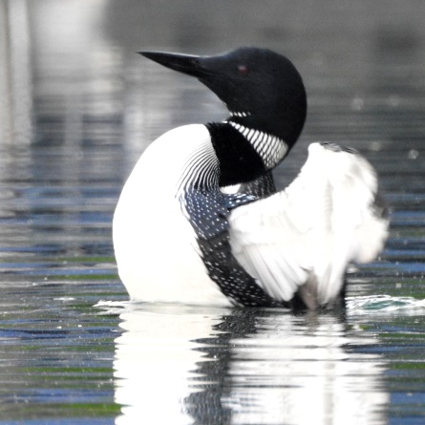**From the Treasurer’s Desk**

Summer taxes are due by Monday, September 16, 2024. The treasurer’s office will be open that day to collect payments. If your payment arrives to Blue Lake Township via US Postal Service and is postmarked on or before September 16, 2024, your payment will be accepted as paid in full. If post marked, hand delivered or put in the drop box after September 16,2024 you will be billed an additional penalty of 1%.per month until paid.

**You can also look up what you owe in property taxes by going to our website** [www.bluelaketwpkalkakaska.org](http://www.bluelaketwpkalkakaska.org)

Under DEPARTMENTS & SERVICES click on TAXES, in the far right-hand column is a PAID/UNPAID list in alphabetical order by last name.

In addition to online credit card payments, you can now pay your tax bill by ACH for a fee. Electronic payments are available on the TAX PAGE of our township website.

Photo courtesy of Ellen Whitehead

dddd

The additional fees are paid to the vendor and not to the township.

**From the Clerk’s Desk**

Michigan’s Local & State Primary Election will be Tuesday, August 6, 2024, from 7am-8pm. The General Election is Tuesday, November 5, 2024, from 7am-8pm. Early voting will be available nine days prior (excluding the Monday before the election) for both elections from 8am-4pm.

You can also print out an Absentee Voter Application request from our website. Under DEPARTMENTS and Services click on ELECTIONS and under Absentee Voting you can click on the link to print the form and mail it, drop it off, fax it, or email it to the Clerk at the township hall.

**From the Zoning Administrator’s Desk**

If you are finishing a basement, adding bedrooms, bathrooms, electrical, etc. don't forget to obtain your building permit from Kalkaska County Building Department and possibly Kalkaska County Environmental Health. If you are adding bedrooms check to be sure your septic meets the required size.   Many people finish basements or add plumbing, electrical systems, and bedrooms without proper authorization. Without the required fire stops and inspections, you are putting yourselves, your neighbors, and your guests at risk. Septic systems are sized based on the number of bedrooms; undersized septic system can lead to serious environmental hazards. Nationwide, fires have decreased thanks to construction codes and smoke alarms, yet some homeowners avoid permits to prevent tax reassessment. However, the potential costs of not complying—such as safety hazards, environmental damage, fines, and complications during home sales—far outweigh any savings on your tax bill. Ensure your projects are permitted and inspected to protect everyone involved.

**Township Planning Commission**

The Planning Commission will meet SATURDAY, AUGUST 17 at 9am for their regular meeting plus a Public Hearing to review proposed changes to the townships Short Term Rental License Ordinance and corresponding revisions to the Zoning Ordinance in section 3.20. The revisions are being considered in response to a resident asking the Planning Commission to determine if Short Term rentals are a Commercial or a Residential purpose. All information will be placed on the Township Website including a history of how this came about. A mailer will be sent in July with more information.

A quick note about how Planning works, the Planning Commission (PC) can take up issues proposed by the Township Board, the Zoning Board of Appeals, the Zoning Administrator, the PC itself, or most importantly, by property owners, as is the case this year for the public hearing. The PC can decide to take up the issue, then it develops revisions to the Zoning Ordinance, approves the changes for a public hearing, then holds the public hearing. After the public hearing, if the PC makes major changes, they hold another hearing. Once the PC approves the changes, the revisions are sent to the County. The County has 30 days to reply, at which point the changes are sent to the Township Board for review. There have been instances where the Board flat rejects the changes, or where they ask for further revisions, which starts the process over, and finally the cases where the Board approves the changes. The Township Board can hold another public hearing, a resident can request a public hearing in writing to the Clerk. If no request is received the Township Board can then approve the changes, which are then published in a newspaper (Kalkaska Review in our case) within 15 days. At this point a township registered elector can file an intent to file a petition for a referendum, which starts several other clocks. If no choice is given, then finally the changes take effect after 8 days of publication.

**Kalkaska Farmers Market**

Enjoy locally grown food and support our local food economy at the Kalkaska Farmers Marker every Tuesday, May to December, from 2-6pm in Downtown Kalkaska’s Railroad Square Pavilion.

**Blue Lake Township Road Improvements**

At the June Township Board meeting, we approved a contract with the Kalkaska County Road Commission to improve the following road in 2024. The township pays 80% of the total cost for repairs with the County paying the remaining 20%.

1. Pflum Road from the township line to Sunset Trail (.5 miles). Overlay with 2 ½” HMA, Spot Wedge, Trenching and adding 23A Limestone Shoulders. Cost to township: $68,094
2. Blue Lake Road (from the culvert on Twin Lake Rd) to Bell Avenue (2.11 miles). Trenching 3” and adding 3” of 23A Limestone Shoulders. Cost to township: $58,852
3. Gedman Road from Starvation Lake Rd. to Sunset Trail (1.62 miles). Overlay with 1.5” of HMA, Spot Wedge, Trenching and adding 23A Limestone Shoulders. Cost to township: $179,910

**Wave Boats/High Water**

**ATTENTION BOATERS! With lake levels still at all-time highs, please be courteous of the erosion caused to our shorelines, seawalls, and homes from high-speed boat wake action.**

DNR watercraft rules require that boating activity stay a minimum of 100 feet away from stationary structures “i.e.: docks, swim rafts or shorelines”. Please travel counterclockwise around the lake.

**Eagle and North Crooked Lake** – slow, no wake.

**Bass, Indian, Little Twin, North Blue and Squaw lake**s – No high-speed boating or water skiing or towing. Boats and Pontoons should go slowly with minimum wake.

**Big Twin, Big Blue, Starvation Lakes** – No high-speed (no wake) boating between 7:30PM – 11:00AM

**Campers and Trailers**

Per our Township Zoning Ordinance outside storage of tents, campers, and travel trailers, motor homes or similar recreational vehicles is prohibited except on parcels with a primary dwelling. This helps keep vandalism down, improves property values, and prevents that abandoned look. Temporary use of tents, campers, travel trailers or motor homes may be permitted for 45 days per calendar year, with a $5.00 permit issued from the Zoning Administrator.

**Township Hall Available**

The Township Hall is available for your personal use. It requires an application to be completed and a $50 deposit. If the usage rules are followed and the hall is left clean, the deposit will be refunded. Call the hall at 231-587-8354 during office hours or visit our web site and look under “Events - Hall Rental” for further information.

**Free Property Fraud Alert for All Kalkaska County Taxpayers**

Sign up today for free alerts to notify of you of ANY documents recorded with your name match in Kalkaska’s land records. If a document is recorded, you will be contacted by phone, text, or email (your choice) within 48 hours. Your contact information is not shared with any entities, it is used strictly for notification purposes. Sign up: [www.propertyfraudalert.com](http://www.propertyfraudalert.com/) Please contact JoAnn DeGraaf, Kalkaska County Register of Deeds with any questions 231-258-3315.

**Burn Permits**

Please add the following web site to your phone/computer to gain information on whether it is legal to burn:

[www.2.dnr.state.mi.us/burnpermits](http://www.2.dnr.state.mi.us/burnpermits). The website is continuously updated. If you touch the County of Kalkaska on the map of Michigan, it will show each township in the county and if burning is authorized. Sometimes burning is only allowed at special times of the day. You can only burn the following: leaves, grass, limbs, brush, stumps, and evergreen needles. No building materials, plastic, rubber, foam, chemical treated wood, textiles, electronics, chemicals, or hazardous materials may be burned. Notice to those who choose to burn: You are responsible for fire, smoke, or odors created from open burning…. And for damage that results from your fire. It is a citable offense if you are not in attendance during the burn. It is also a citable offense if you are burning without a permit.

**Kalkaska Library Satellite Location**

The Kalkaska Library has set up a satellite location at the Coldspring Township Office located at 6515 County Road 571 NE, Mancelona. You can now pick up and return books for the Kalkaska Library there on Thursdays from 9AM-6PM. They will soon be adding Bestsellers, Wi-Fi Hotspots and more. Plus, public computers, printing and fax service will be available. Watch for more special events and programs coming to this location at [www.kalkaskalibrary.org](http://www.kalkaskalibrary.org) or call (231)258-9411.

**Broadband Service**

The Township maintains a Public Access Wi-Fi system at the Township Hall. If you have a compatible computer, you can use it in and around the Township Hall to access the Internet. It works in the parking lot but if you are there during office hours come in and use the table inside.

**Township Recycle Locations**

GFL Recycle County bins are available at CETA Hall and behind the Kaliseum. Bins will be emptied by GFL every Monday, Wednesday, and Friday.

**Kalkaska Public Transit Authority**

Kalkaska County Residents 60 years of age and older can ride free of charge on all KPTA buses. This Senior Ride Free program is provided through a contract between Kalkaska Public Transit Authority and Kalkaska County Commission on Aging. Currently the service is for transportation within Kalkaska County only and does not apply to trips going into Grand Traverse County. For additional information regarding this service, please feel free to contact KPTA at 231-258-6808 or the COA at 231-258-5030.

**Kalkaska Memorial Health Center**

Kalkaska Memorial Hospital has 24/7 emergency services that are available with new physicians and extended services. Located at 419 S Coral Street. Visit their website [www.munsonhealthcare.org/kmhc](http://www.munsonhealthcare.org/kmhc) for more information. KMHC has also opened a Walk-in Care Clinic attached to the Medical Associates Offices. The first check-in window is dedicated to walk-in registration. No appointments are necessary. All patients are welcome and served on a first come first served basis. The clinic is open Monday thru Friday Noon - 8 PM. Saturday from 8 AM - Noon. They are closed on Sunday. Office call pricing will be charged for each visit.

### Trash Pickup

**Residential trash pickup is on Monday by GFL Environmental with a 5-bag limit per household.** Boxes of garbage or large items that do not have a sticker on them will not be picked up. **Household items only, no construction material will be collected.** If a holiday falls on Monday, pickup will be on Tuesday. Please do not put out trash that is not bagged - our contract with GFL Environmental is for bagged trash only. If you put your trash out before Monday morning, please have your trash in an animal proof receptacle. Dogs, cats, ravens, and raccoons are just some of the critters who love to spread trash around. FYI: scattered trash violates the nuisance ordinance, and a ticket may be issued. Large items require a sticker for pick-up and are available at the township hall.

**Greenbelt Law Reminder**

It is very important for the life of our lakes that some land near the water be maintained in its natural state. For this reason we have a Greenbelt Law as part of our zoning ordinance. The ordinance limits what can be done of the strip of land measuring 25 feet wide from the hight water meander line of the lakeshore. Trees, shrubs and grass may be planted to protect the bank from eroding or to improve aesthetics. Trees and shrubs may be pruned for a better view of the water but major changes including removal of trees are not allowed. If in doubt what you can or cannot done near the waters edge, please call the Zoning Adminstrator before you act. You can view Zoning Requirement and Permits requirements online at our website under: DEPARTMENT and SERVICES, click on Zoning and Permits. You will find these on the right-hand side of the page.

**Land Values in Blue Lake Township for 2024**

|  |  |  |  |  |
| --- | --- | --- | --- | --- |
| 1 Acre | $9900 |  | Bass Lake | $330 FF |
| 2.5 Acre | $22,500 |  | Big Twin Lake | $2,500 FF |
| 5 Acre | $28,750 |  | Little Twin Lake | $910 FF |
| 10 Acre | $31,000 |  | North Blue Lake | $1,000FF |
| 20 Acre | $66,000 |  | Eagle Lake | $330 FF |
| 40 Acre | $79,400 |  | Big Blue Lake | $1,750 FF |
| 50Acre | $97,500 |  | South Blue Lake | $330 FF |
| 100 Acre | $160,000 |  | Crooked Lake N & S | $330 FF |
|  |  |  | Indian Lake | $610 FF |
|  |  |  | Squaw Lake | $610 FF |
|  |  |  | Starvation Lake | $1,470 FF |

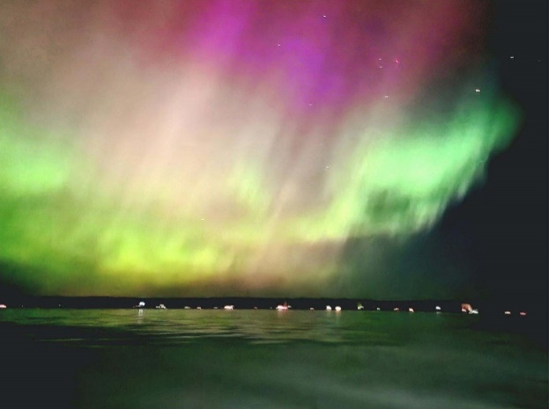

Photo courtesy of Cindi Anderson, Big Twin Lake

**Have a wonderful summer and remember to slow down**

**for walkers and bikers on the road.**

**Visit our website** [**www.bluelaketwpkalkaska.org**](http://www.bluelaketwpkalkaska.org)

**for more township information**